Contents
Day1-Typescript Basics 1
Day2-Arrow functioning 2
Day3: Getters & Setters methods in TS-assessors and mutators 5

Day1-Typescript Basics
- type "code ." in cmd- to open IDE
- typescript -product of microsoft,a transpile language
- npm install -g typescript(after insatalling node)
- Typescript code->tsc->Transpile into->Javascript code=Tranpilation Process(Converting one source code to another source code)
- strongly typed -datatypes(But javascript ,no datatypes)
- var age=12;//venila code
- var age:number=12;//ECMA script
- ts only for development purposes,not for production.(Developer point of view)
- Modern browser dnt understand ECMAscript 6
- ECMAscript is a standard of js
- Typescript has all the features of ECMA script
- Typescript is a superset of ECMAscript
- OOPS in ts.
- commonjs(venila js/pure js)
- eg:class Employee{
}
- Above code will not be understood by modern browser-it is converted as "function Employee{}(this is a commonjs )
- js is a functional language.
- var age:any=12;//no typeinference
- tsc-typescript compiler(ts code ->js code)
- it produces js file even if u have errors in ts file
- tsconfig.json file(compile all ts files into a bundle)
- tsc --init-Successfully created a tsconfig.json file.
- tsc -w(trigger watch operations)
- put "outdir=./js" and "watch":true," in tsconfig.json
- type "tsc" and press enter-it watches for tsconfig.json file and watch for file changes
- remove "module" and change target as es6
- es6 is a flavor of js
- let is nt there in 100%js
- let is a feature of es6
- create index.html file and "!" is typed,then press tab
- type "live-server" in terminal to open browser to see changes simultaneosly
- give <h1>welcome</h1>-"Welcome" is seen in browser
function getData(name:string,age?:number){}
getData("34");
parameters-1st is mandate,2nd is optional
here getData(34) will throw an error showing that "Argument of type '34' is not assignable to parameter of type 'string'"

Day2-Arrow functioning
- to replace the annonymous function
- function is also an object in js
- enable " "noImplicitAny": false, "noImplicitThis": false, , "sourceMap": true, ....debug in ts file opens in google developer tool.
- dnt use let,var,const in class
- funtion of a class cn contain var,let,const
- in class,only one constructor(with parameter/without parameter)
- diff path of constructor is allowed
class TodoApp implements ITodoService{
arr:Todo[]=[{name:"gayu"},{name:"b"}];
id:number=0;
age:number=0;
constructor(id:number,age:number)
{
this.id=id;
this.age=age;
}

constructor(private id:number,private age:number)
- dnt use the keyword "function" in class while declaring a function
Refer
interface Todo
{
name:string;
completed?:boolean;
}
interface ITodoService{
getAllTodo(id:number):Todo[];
}
abstract class Parent{

demo():number
{
return 10;
}
}
class TodoApp extends Parent implements ITodoService{
arr:Todo[]=[{name:"gayu"},{name:"b"}];
/* id:number=0;
age:number=0; */
constructor(private id:number,private age:number=0)
{
super();//calling base class constructor
/* this.id=id;
this.age=age; */
}
getAllTodo(id:number)
{
return this.arr;
}
demo():number{
return super.demo()+10;//calling base class method
}
}
let Todonew=new TodoApp(4);
//var p=new Parent();//cannot create obj for abstract class
Todonew.getAllTodo
var myTodo:Todo={completed:true,name:""};
console.log(myTodo);

Day3: Getters & Setters methods in TS-assessors and mutators
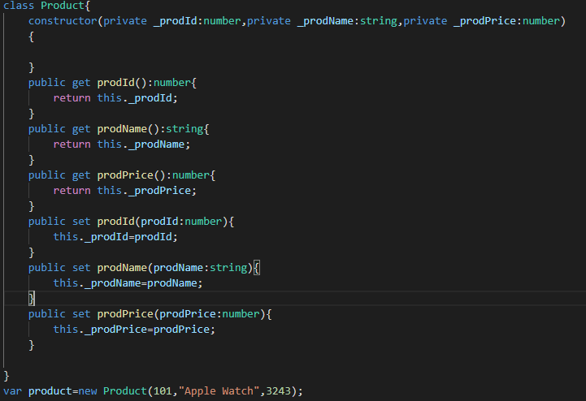
Setting value to variables as:
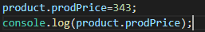
See here, we are Accessing variables by variable name rather than method call
String templating-string interpolation(Angular)
Normally
var status:string="Your Task "+(todo.completed?'IS' : 'IS NOT')+" Completed";
in TS
var status:string=`Your Task ${todo.completed?'IS' : 'IS NOT'}`+" Completed";
here we ${} to bind the ternary operations to string.

https://github.com/SabariRepo/angularjuly2019open

